**Project Purpose**

To give information what is available to do in or near Rexburg, Idaho area.

**The Audience**

My main audience are student. Both male and female from the ages 18-27. It can also range to anyone that is unfamiliar to the area of Rexburg. Since students are my audience it will influence what kind of info on my websites. Usually students are low on money so they want things to do that doesn’t cost too much money. They also want things that they can do on a date or in a group of friends. The activities need to be close to the area because most students don’t have great modes of transportation.

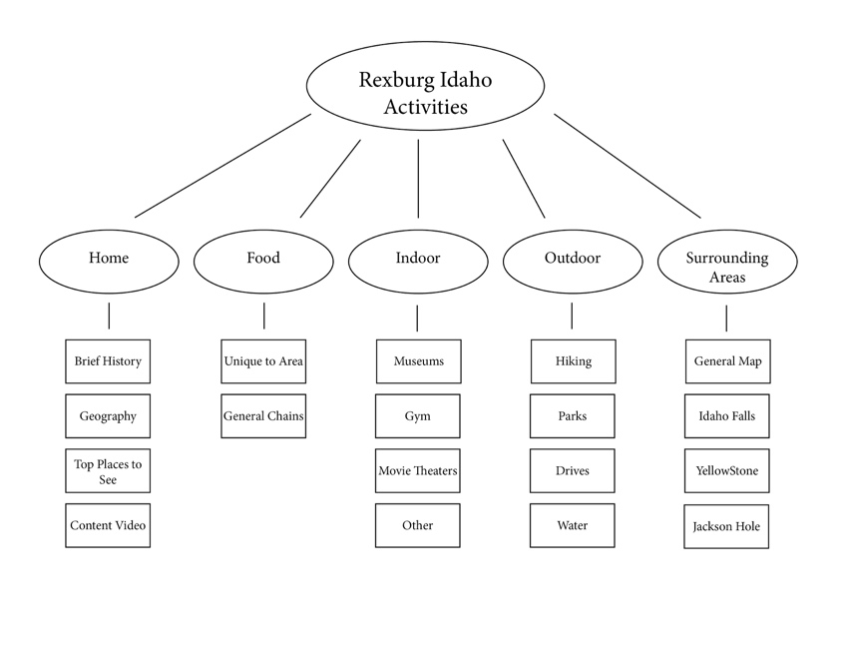**Web Pages:**

Home Page: Brief History of Rexburg, Geography, content video, and the top places to see in Rexburg with links to associated content pages.

Food: Places for people to eat unique to Rexburg.

• the burg

• gator jacks

• el rancho

Indoor: Indoor activities to do in Rexburg

since the winters can be rough.

•fat cats

•rexburg tabernacle

• rock climbing

Outdoor: Outdoor activites…There are many beautiful things in Rexburg. It is also the cheapest things you can do in Rexburg.

•porter park

• darby wind caves

•goldbug hot springs

Experiences: Testimonials of the fun things to do in Rexburg, Idaho. A peek into social media posts.

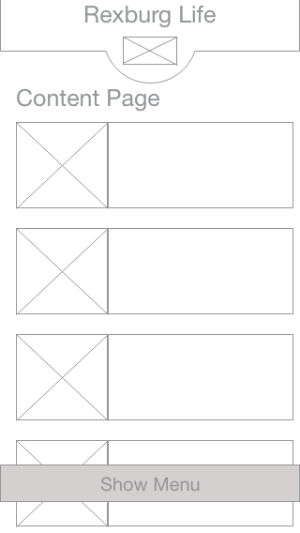**Wireframe Sketches**